Software Design Document

<Victoria Road Crash Data Software>

Group 52

Student Names

S5234269 Saikat Dutta Tanu

Table of Contents

1.0 System Vision 3

1.1 Problem Background 3

1.2 System Overview 3

1.3 Potential Benefits 3

2.0 Requirements 4

2.1 User Requirements 4

2.2 Software Requirements 4

2.3 Use Cases 4

3.0 System Components and Software Design 5

3.1 System Components 5

3.2 Software Design 5

4.0 User Interface Design 6

# System Vision

## Problem Background

The software will be developed to provide road safety data based on time, location, condition, type of collision, type of road user, object hit. based on Victoria Road Crash Dataset provided by Vircord. To reduce traffic accidents and risks in Victoria. In addition, the software analyses the point of occurrence of an accident and provides visualized insight to help user understand.

## System Overview

The system will be developed to make the people of Victoria aware of the traffic to reduce the number of accidents. It will be a python programmed software through which people of Victoria can easily trace the time, location, condition, type of collision and road user and object hit. Python will be used to develop the software.

## Potential Benefits

The number of road accidents can be reduced as well as the fatality caused by the accidents. People can analyse the data provided to them through the software and thus take decisions according to them.

# Requirements

## User Requirements

The user just needs to install the software to get the data from the software.

## Software Requirements

R1.1 The program shall be written in Python Programming language.

R1.2. The software shall be able to analyse the dataset and it shall be just a software through which the user will be able to see the information stored in the software.

R1.3. The program shall use python strings as data structure.

## Use Cases & Use Case Diagrams

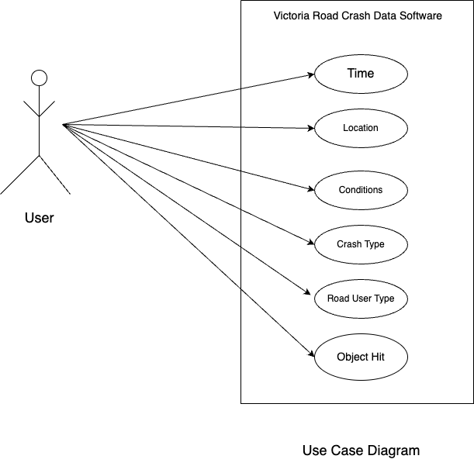

# Software Design and System Components

## Software Design

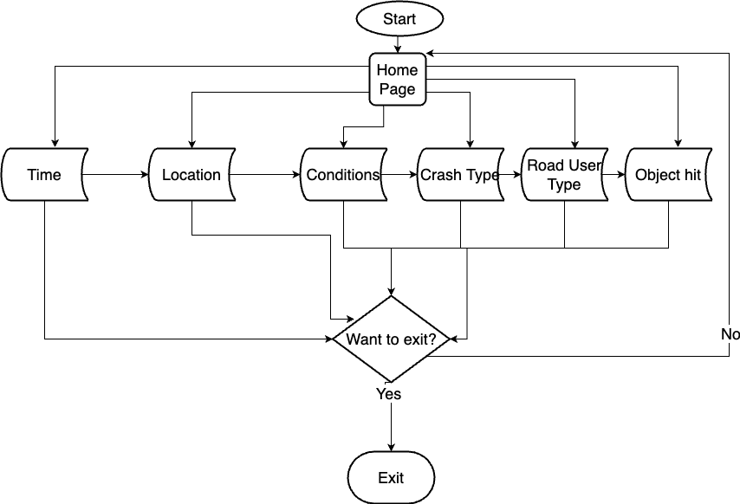

## System Components

### Functions

List of all functions which is used to develop the software:

1. Time: This function is used to highlight the time while the road accidents occurred.

Input Parameter: time().

Datatype: Datetime which was imported from Python library

2. Location: It was used to display the location of the accidents and accident prone zones.

Input Parameter: location()

Datatype: Strings.

3. Conditions: It was used to show the conditions of the traffic and road.

Input Parameter: conditions()

Datatype: Strings.

4. Crash Type: Returns the types of crash that occurred.

Input Parameter:crash_type()

Datatype: Strings.

5. Road User Type: This function was used to print the type of road users.

Input Parameter: road_user_type()

Datatype: Strings.

6.Object Hit: That function displays the type of objects hit by the vehicles.

Input Parameter: object_hit()

Datatype: Strings.

### Data Structures / Data Sources

Python Strings(Arrays) will be used in this software frequently. As we know, strings in Python are arrays of bytes representing unicode characters. Arrays will be used in inputting the parameters of the functions.

List of functions that will use python strings(arrays):

1.location()

2.conditions()

3.crash_type()

4.road_user_type()

5.object_hit()

### Detailed Design

Pseudocode for all non-standard / non-trivial algorithms that operate on data structures

# User Interface Design

## Structural Design

Structural design refers to the navigational and information structure of your product – the structure that supports the interface layout. How will you structure your product? How will you group your information? How will you navigate through your product? Why? This can take the form of a diagram showing structure and hierarchy, supported by a discussion and justification of your choices. Why have you made these design choices? Describe and outline the structure of your interface and of your information.

## Visual Design

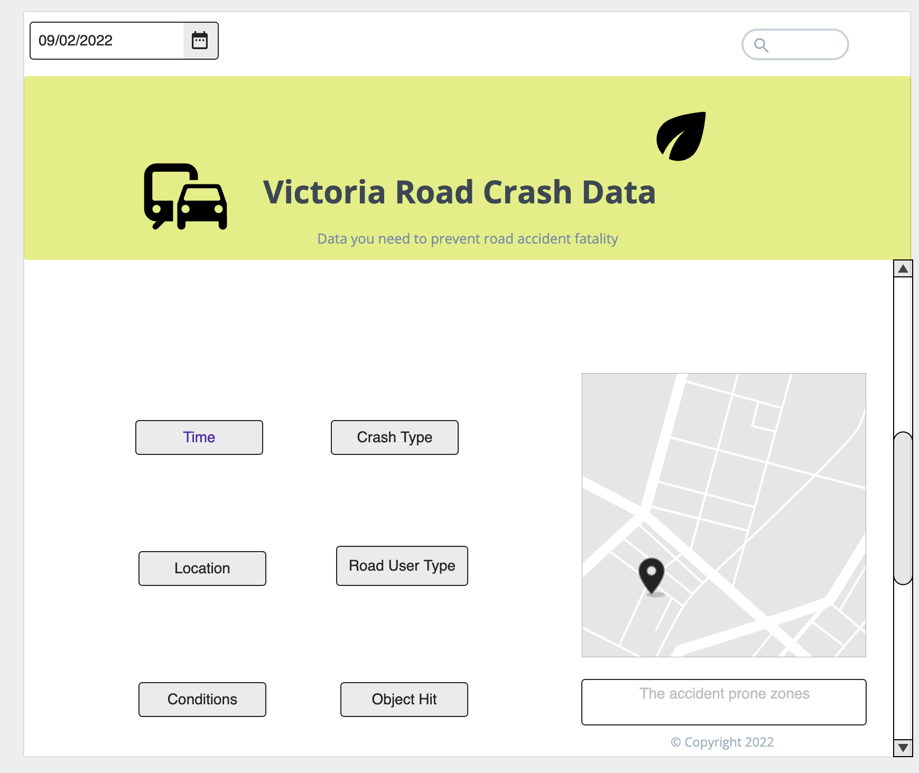

I have used an online visual design development website/tool named app.moqups.com was used to develop the visual design. This is just a mockup. I have chosen buttons in grey colour as it will be more convenient for the users to read the options of the buttons. The software name is highlighted with large fonts and it in black colour with yellowish background.